Warm Up Guidelines (By Ian Ingman COLSC Coach)
- Before you start your warm up sip your drink and ensure to take your drink with you to the end of your lane and drink it whilst warming up.

- Before you enter the water, carry out a land warm up for about 5 to 10 minutes which should consist of a range of arm and leg swings, not stretching, may be skipping etc.

Water Warm Up
- 300m Fullstroke, can consist of Bk/s and Fr/s – medium pace, just warm up the muscles and getting your body used to the temperature of the water.

- 500m / 600m made up of (8/10 x 50m) or (5/6 x 100m) distances working on specific race stroke skills such as stroke technique, fullstroke, drill, kick, pull etc to get a good feel for the water and specific race stroke. A rest of 15 to 20 seconds between swims.

  - Please ensure you bring all equipment that is required to the competition such as a pullbuoy & float to be able to carry out your warm up correctly. Plan ahead!

- 100m Fullstroke – working on stroke length and technique with short sprints of 6 strokes on each length
Pacing or sprints
- Pacing can be done for distance events were you try to hit specific target times over a set of 6 to 8 x 50m swims. Sprints can be 2 to 4 x 25m sprints - sprinting to half way, easy to the end of pool.
You can set yourself a target time for your sprints by using the following formula.
100m PB – 5 seconds ÷ 8 = 12.5m target time for 25m Pool Sprints or
100m PB - 5 seconds ÷ 4 = 25m target time
- 25m Sprints - Think of block starts; streamlined position underwater and kick, breakout and pick up of fullstroke at pace but don't shorten your stroke length when swimming fast, stay relaxed and long.

- 200m / 400m Swim Down loose and easy working on 200m Fr/s or Bk/s, 2 to 3 x 100m IM drills, 4 x 50m Fr/s with 10m Sprint Kick. You can also do some relaxed kicking to aid the swim down and bring your heart rate down as well.

11. Get out and have a shower and relax, dressed in dry race suit, (girls if you have a long time to wait before you race, don’t put your shoulder straps on as this can make your neck stiff and saw, leave them under your arms) put polo shirts on, tracksuits, shorts and trainers or any combination etc. Don't walk around with nothing on your feet especially if you are to get some fresh air between race’s which is vital and will make you feel better and refreshed.

12. Relax before the race.
13. Eat a small snack and have a drink after warm-up. You must drink and eat kit bag carbs, snacks, energy bars, biscuits, bananas, sandwiches etc to replenish energy after warm up and before race / warm down and further races.

14. Start your land warm up at least 15 minutes before going to swim.
15. Check you’ve got all your equipment before you report for your race i.e. two pairs of goggles, two caps and a towel. Spare equipment is required just in case your goggles snap or your cap rips when you are getting onto the blocks.
16. Report to the poolside marshal for your race.
17. Stay relaxed and flexible and keep in the zone and focussed on your job at hand.

Why do we need to swim down?  By Sue Taylor, Senior Lecturer in Sport and Exercise Physiology  - What happens to your body after a race?  - Why do we need to swim down? |  |  |  |  | 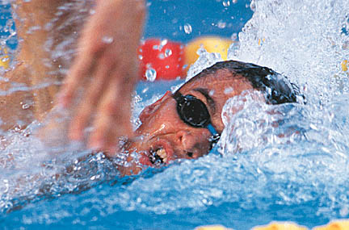
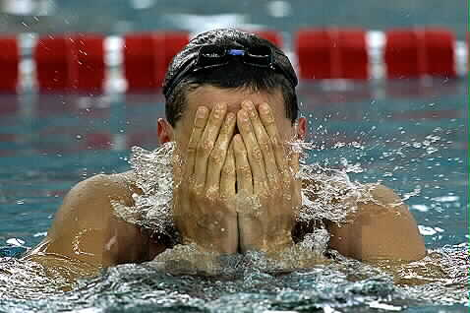 |  |  | After a race….  - Increased lactate levels  - Increased waste products in the blood  - Increased heart rate  - Increased breathing rate  - Increased adrenaline (excitement) ...
Main goal after a race….  - Reduce lactate levels to resting levels  - Remove waste products from the blood  - Reduce heart rate and breathing rate to resting levels  - Restore energy stores |  |  |  | 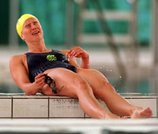
What is the best way to remove lactate?
Passive Recovery  (Just sit and do nothing!!!) |  | Passive recovery after a race or maximal effort failed to significantly reduce lactate levels even after 30 min.
Massage |  | Similar to passive recovery - levels still high after 30 min. BUT good for relaxation of body and mind (before or after race).
Active Recovery  (e.g. Swim down) |  | Shown to be the BEST method of lactate removal.  The more muscles involved the more rapid lactate removal will be
How does the body remove lactate?
  Swim Down | The lactate produced by the muscles during a maximal swim moves to the blood where it is used by the muscles, liver and the heart.  This is achieved by increasing the blood flow to the muscles, which delivers more oxygen and nutrients to the muscles and allows the waste products to be removed.  This process produces heat, which causes the body to become dehydrated - this will affect your next swim.
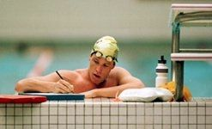  Practical Guidelines… | - Don’t just sit there - keep moving!!!  - Swim down:  - INTENSITY: Moderate (Swim-Kick-Drill-Pull)  - DURATION: approx. 20 min + (minimum of 800m)  - No swim down facility…go for a run, row, skip, etc. Anything which keeps your muscles active - but remember must be a low intensity for approximately 20min.  - Rehydrate - make sure you have a sports drink after your swim. If you are dehydrated you cannot swim your best no matter how hard you try!!!
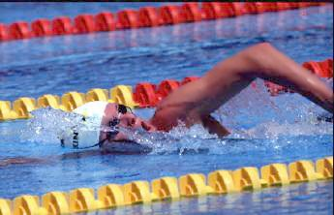  Why bother? | What will happen if you don’t swim down?  - You will not be able to swim fast in your next race / your training will start to suffer.  - You will start to get tired early in the race / you will be too tired to train.  - You will not perform to your best in training or at a competition.

SWIM DOWN PROTOCOL

Swimmers should attempt to keep moving as soon as they have completed a race, this includes moving the arms and legs in the water, and stretching and moving arms and legs out of the water on the way to the swim down pool. A swim down should be adjusted to your age, size and the event you have just swam but should not be any shorter than 600m minimum distance.

- Remove a race costume before swim down if possible quickly and replace with a swim down, general, old costume.

- Report to the swim down pool within 3 minutes of the end of a race with a full drinks bottle and food such as a biscuit or snack bar.

- Replacement fluid should be drunk immediately and taken at every opportunity throughout the swim down.

- Swim 200m ‘Own Choice’ Easy, own pace and stroke with unrestricted breathing if possible.

- Swim 400m, or 4 x 100m with 30s rest, alternating 100’s Freestyle and Backstroke.

- Swim 8 x 50m with 20s rest, use 3 mixed strokes (no fly) and focus on kicking the legs, can include legs only

- Swim 4 x 100m with 30s rest alternate Freestyle, Backstroke and or IM Drills.
- Bursts of 10 - 15m speed at the start of each swim
- Take your Heart Rate after each swim. Your Heart Rate should be approximately 50 - 60 beats below maximum but not lower as this will not aid your swim down or your body removing lactate acid from your blood stream.

- After 2 minutes rest, sitting on floor, check your Heart Rate
- If below 100 BPM (Beats per minute) your Swim Down is complete
- If above 100 BPM (Beats per minute) continue your Swim Down.

- Swim 4 x 100m with 30s rest alternate Freestyle, Backstroke and or IM Drills.
- Bursts of 10 - 15m speed at the start of each swim
- Take your Heart Rate after each swim. Your Heart Rate should be approximately 50-60 beats below maximum but not lower as this will not aid your swim down or your body removing lactate acid from your blood stream.

- After 2 minutes rest, sitting on floor, check your Heart Rate.
- If below 100 BPM (Beats per minute) your Swim Down is complete
- If above 100 BPM (Beats per minute) continue your Swim Down.

- Swimmers should complete their swim down before talking to their coach.
- A coach may give their swimmer a couple of brief comments or positive pointers on the way to the swim down pool.
- A full discussion and feedback should take place once the swim down is complete.

